|  |
| --- |
| Simac IT NL |
| How to stimulate motivation in a large workforce? |
| Team Uplifting Onion |

|  |
| --- |
| Genechten,Luke L.A.R. van | Doan, Jenny Kim J.K.  17-3-2023 |

Inhoud

How to stimulate motivation in a large workforce? 2

Methods 2

Results 3

Types of Motivation 3

A Third Type of Motivation? 3

Employee input 3

Validation 3

Achievements 3

Cleanliness 4

Teambuilding 4

Mental health 4

Employee needs 4

Conclusion 6

References 7

# How to stimulate motivation in a large workforce?

For this research document, the goal is to figure out how motivation can be stimulated in a work environment, specifically Simac IT NL. In the process, we will challenge Simac's assumption that compliments are the goal of this project and research if there is more to motivation than just giving compliments.

## Methods

The research method used in this document is a literature study. Using well substantiated sources, our results and conclusions will be detailed below.

## Results

## Types of Motivation

The two main types of motivation are frequently described as being either extrinsic or intrinsic.

* [**Extrinsic motivation**](https://www.verywellmind.com/what-is-extrinsic-motivation-2795164) arises from outside of the individual and often involves external rewards such as trophies, money, social recognition, or praise,
* [**Intrinsic motivation**](https://www.verywellmind.com/what-is-intrinsic-motivation-2795385) is internal and arises from within the individual, such as doing a complicated crossword puzzle purely for the gratification of solving a problem.2

## A Third Type of Motivation?

Some research suggests that there is a third type of motivation: family motivation.3 An example of this type is going to work when you are not motivated to do so internally (no intrinsic motivation), but because it is a means to support your family financially.

Source: <https://www.verywellmind.com/what-is-motivation-2795378>

## Employee input

To make sure that employees are satisfied with their work and are happy, it is important to ask for their input. Through the use of surveys, this can be achieved.

<https://www.indeed.com/career-advice/career-development/motivation-techniques-for-the-workplace>

<https://www.indeed.com/career-advice/career-development/motivation-strategy>

Validation

Aside from surveys, the way to actually improve motivation can be done in a multitude of ways. One of which is validation of good work. In a lot of companies, doing something bad will certainly give you negative feedback, but doing your work well will not always grant the same amount of positive feedback.

This has a two-fold advantage. Not only does it raise motivation, it also increases happiness, both of which are very closely related. Music, games and of the course the friday afternoon drink will all help achieve this goal.

Achievements

For big projects, milestones should be celebrated. This ensures that it really feels like everyone achieved something great whilst doing their work.

These celebrations are important, but are also only long term. So for the shorter term, the project should be divided into bits. Smaller goals are easier to see through to the end, because it doesn't require such a large time investment.

Cleanliness

Even the office environment is important to improve motivation. By far the most important factor in this is a clean office. Not sterile, but definitely not cluttered, as this will cause a chaotic feeling around the office. Research shows that a cluttered environment causes poor mental health, less efficient thinking and even unhealthier eating (<https://www.psychologytoday.com/us/blog/fulfillment-any-age/201705/5-reasons-why-clutter-disrupts-mental-health>).

## Teambuilding

Team building plays another important role in increasing employee motivation. Social bonds on the work floor will help with motivation and also hapiness.

## Mental health

In order for compliments to actually work, it is important to secure mental health of everyone in the workspace. This way, it becomes easier for everyone to become motivated and exchange personal conversation outside of work.

While there are many ways secure mental health for everyone, these are a few important methods on achieving this.

* Create a safe space for everyone in the company. A corporate culture that normalizes talking about mental health issues can make it easier for employees to answer questions about health habits and mood,
* Ask the right questions. While asking how someone is doing, the answer they give may not give the full picture of their mental health. It is better to ask a question that can give a more full picture of that,
* Observe the workforce. Give management and HR the training to identify signs and symptoms of stress, anxiety, and depression. Pay attention to people’s major life events. Team of influencers can also notice minor behaviors and clues that individuals may give without even knowing it.

Source: <https://blog.wellsource.com/10-strategies-to-improve-mental-health-in-workforce-populations>

## Employee needs

In order to motivate employees, it is important that all five of the Maslow's hierarchy area's are fulfilled. Motivation on a level like giving compliments or teambuilding will not work if needs like food or health are not met.

<https://positivepsychology.com/improving-motivation-at-work/>

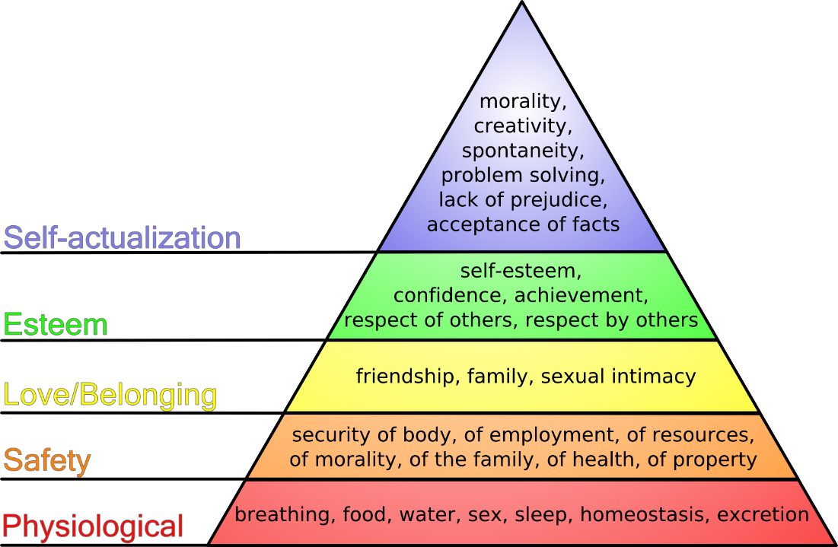

# Conclusion

Clearly, giving compliments on the workfloor is an important step to a healthy, happy and motivated workforce. However, there also is a lot more to motivation than just compliments. To motivate people in the workspace, it is important that all the basic needs of everyone is fulfilled like food and health. Companies should then try various methods to secure motivation of everyone by:

* Asking for their input
* Validation of good work
* Celebrating achievements
* Maintaining a clean workspace
* Creating good teambuilding and social bonds

Aside from motivation, it is also very important to pay attention to mental health. This will not only help maintain motivation, but also make personal exchanges easier. This can be done by:

* Creating a safe space at work,
* Asking the right question about someone’s mental health,
* Observing the workforce to identify symptoms of stress, anxiety or other problems.

# References

Indeed Editorial Team. (2023, February 4). *10 Motivation Strategies To Increase Employee Productivity*. Indeed Career Guide. <https://www.indeed.com/career-advice/career-development/motivation-strategy>

Herrity, J. (2023, February 28). *12 Effective Motivation Techniques for the Workplace*. Indeed Career Guide. <https://www.indeed.com/career-advice/career-development/motivation-techniques-for-the-workplace>

Candidate, B. S. M. P. (2023, March 3). *The Science of Improving Motivation at Work*. PositivePsychology.com. <https://positivepsychology.com/improving-motivation-at-work/>

Whitbourne, S. K., PhD. (2021, March 30). *5 Reasons Why Clutter Disrupts Mental Health*. Psychology Today. <https://www.psychologytoday.com/us/blog/fulfillment-any-age/201705/5-reasons-why-clutter-disrupts-mental-health>

Wellsource, Inc. (2022, May 19). *10 Strategies to Improve Mental Health in Workforce Populations*. <https://blog.wellsource.com/10-strategies-to-improve-mental-health-in-workforce-populations>

Cherry, K. (2022, October 22). *What Is Extrinsic Motivation?* Verywell Mind. <https://www.verywellmind.com/what-is-extrinsic-motivation-2795164>

Cherry, K. (2022b, November 14). *What Is Intrinsic Motivation?* Verywell Mind. <https://www.verywellmind.com/what-is-intrinsic-motivation-2795385>